Thesis Completion Certificate

Student Name: ________________________ Enrolment No: ___________

Student Name: ________________________ Enrolment No: ___________

Programme of Study: Bachelor of Software Engineering

Project Title: _____________________________________________________

It is to certify that the above students’ project has been completed to my satisfaction and to my belief, its standard is appropriate for submission for evaluation. I have also conducted plagiarism test of this thesis using HEC prescribed software and found similarity index at ___________ that is within the permissible limit set by the HEC. I have also found the thesis in a format recognized by the department.

Supervisor’s Signature: __________________________

Date: _________________________ Name: ____________________________

Certificate of Originality

This is certify that the intellectual contents of the project __________________________________________________________________________________________________________________________________________

are the product of my/our own work except, as cited properly and accurately in the acknowledgements and references, the material taken from such sources as research journals, books, internet, etc. solely to support, elaborate, compare, extend and/or implement the earlier work. Further, this work has not been submitted by me/us previously for any degree, nor it shall be submitted by me/us in the future for obtaining any degree from this University, or any other university or institution. The incorrectness of this information, if proved at any stage, shall authorities the University to cancel my/our degree.

Name of the Student: ___________________________

Signature: _______________________ Date: _________________

Name of the Student: ___________________________

Signature: _______________________ Date: _________________

Abstract

The FYP Management System is a comprehensive web application designed to streamline and automate the management of Final Year Projects (FYPs) in our university. The system provides a user-friendly interface that caters to different user roles, including students, supervisors, coordinators, evaluators, and the Head of Department (HOD).

Through the FYP Management System, students can easily browse and connect with supervisors, submit project proposals, and track the status of their submissions. Supervisors have the ability to review and accept or reject student responses, create and assign tasks to their assigned student groups, and monitor the progress of their projects. Coordinators play a crucial role in the system by creating project plans, assigning evaluators, and overseeing the overall progress of FYPs. Evaluators can evaluate student submissions based on predefined criteria and provide feedback and grades.

The system incorporates various functionalities to support the project management process, including the creation of project groups, task assignment, document submissions, evaluation, and feedback. It ensures seamless communication and collaboration among project stakeholders, facilitating effective project coordination and monitoring.

In terms of system implementation, the FYP Management System is developed using the MERN (MongoDB, Express.js, React.js, Node.js) stack, taking advantage of modern web development technologies. The system integrates with external components such as the database server and authentication systems to ensure secure and efficient data exchange.

The FYP Management System addresses several functional requirements, including the ability to view and respond to project ideas, submit project proposals, create and manage tasks, and evaluate student submissions. It also meets important interface requirements, providing a user-friendly interface accessible through web browsers on various devices.

Furthermore, the system adheres to non-functional requirements, including security, performance, usability, modifiability, reliability/availability, and interoperability. Project feasibility has been assessed in terms of technical feasibility, operational feasibility, and legal and ethical feasibility.

In conclusion, the FYP Management System offers an integrated and efficient solution for managing Final Year Projects in our university. With its user-friendly interface, robust functionalities, and adherence to various requirements, the system provides a valuable tool for enhancing the project management process and facilitating successful FYP completion.

**Keywords:** Streamlined project management, web-based FYP management, student-supervisor collaboration, task assignment and tracking, document submission and evaluation, efficient project coordination, MERN stack development, final year project success, integrated project management system, seamless project communication.

Dedication

To the pursuit of knowledge, the passion for learning, and the relentless pursuit of excellence, this work is dedicated. It is dedicated to the dreamers, the innovators, and the seekers of truth who dare to push the boundaries of knowledge.

This dedication is extended to all the students, supervisors, coordinators, evaluators, and administrators who have embarked on the journey of education and research. It is a testament to their unwavering commitment, tireless efforts, and unwavering dedication to shaping the future through the power of knowledge.

In the spirit of collaboration and the quest for academic achievement, this work is dedicated to the collective efforts of the academic community. It is a tribute to the countless hours spent in classrooms, laboratories, and libraries, all in pursuit of expanding the frontiers of knowledge.

May this dedication serve as a reminder of the immense value of education, the transformative power of research, and the indomitable spirit of those who embark on this noble endeavor. Let it ignite a spark of curiosity and inspire future generations to embrace the pursuit of knowledge, for it is through knowledge that we illuminate the path to a brighter future.

This dedication is a humble tribute to the intellectual giants of the past, the present, and the future, whose tireless dedication and thirst for knowledge have shaped the world we inhabit. May their legacy live on in the minds of those who continue to seek understanding and strive for progress.

To all who share a deep passion for learning, to those who dare to question, to challenge, and to dream, this work is dedicated. May it serve as a testament to the power of knowledge and the transformative potential that lies within each and every one of us.

Acknowledgments

In the name of Allah, the Most Gracious, the Most Merciful. All praise and thanks are due to Him alone, the Lord of all worlds.

I would like to express my deepest gratitude and heartfelt thanks to Allah for His guidance, blessings, and endless mercy throughout this journey. His unwavering support has been my constant source of strength and inspiration.

I am truly grateful to my supervisor Sir Aleem Ahmed and coordinator Sir Raja Suleiman for their invaluable guidance, mentorship, and continuous support throughout the research process. Their expertise, patience, and encouragement have been instrumental in shaping this work.

I extend my sincere appreciation to my family for their unwavering love, encouragement, and unwavering support. Their belief in me and their sacrifices have been the driving force behind my success. I am forever grateful for their presence in my life.

I am deeply indebted to my friends and classmates for their support, motivation, and insightful discussions. Their camaraderie and shared experiences have made this journey memorable and rewarding.

I would like to express my gratitude to the staff and faculty of [Bahria University Islamabad] for providing a conducive learning environment and the necessary resources for this research. Their dedication to academic excellence has been invaluable.

I would also like to thank all the participants who generously shared their time, knowledge, and experiences for this study. Their contributions have enriched this work and provided valuable insights.

Finally, I would like to acknowledge the countless researchers, scholars, and pioneers in the field whose contributions have paved the way for this study. Their dedication to knowledge and pursuit of truth continues to inspire and motivate me.

To everyone who has played a role, big or small, in supporting me throughout this journey, I offer my heartfelt thanks. May Allah reward you abundantly for your kindness, patience, and encouragement.

All praises and thanks are due to Allah, and any errors or shortcomings in this work are solely my own. May this research be a source of benefit and contribute to the advancement of knowledge in the service of humanity.

"And say: My Lord, increase me in knowledge." (Quran 20:114)

Table of Contents

Thesis Completion Certificate ii

Certificate of Originality iii

Abstract iv

Dedication v

Acknowledgments vi

List of Figures ix

List of Tables x

Chapter 1 1

Introduction 1

1.1. Motivation 1

1.2. Problem statement or research questions 1

1.3. Objectives 1

1.4. Main contributions 1

1.5. Report organisation 1

Chapter 2 3

Background Study/Literature Review 3

2.1. Key Concepts 3

2.1.1. Subsection 3

2.2. Subsections 4

2.2.1. Sub-subsection 4

Chapter 3 5

System Requirements 5

3.1. Use Case Diagram 5

3.2. Functional Requirements 5

3.3. Interface Requirements 5

3.4. Database Requirements 5

3.5. Non-Functional Requirements 5

3.6. Project Feasibility 6

3.7. Analysis Models 6

3.8. Conclusion 6

Chapter 4 7

System Design 7

4.1. Design Approach 7

4.2. Design Constraints [Optional] 7

4.3. System Architecture 7

4.4. Logical Design 7

4.5. Dynamic View 7

4.6. Component Design 7

4.7. Data Models 8

4.8. User Interface Design 8

4.9. System Prototype 8

4.10. Conclusion 8

Chapter 5 9

System Implementation 9

5.1. Section 9

5.2. Conclusion 9

Chapter 6 10

System Testing & Evaluation 10

6.1. Test Strategy 10

6.2. Component Testing 10

6.3. Unit Testing 10

6.4. Integrated Testing 10

6.5. System Testing 10

6.6. Test Cases 10

6.6.1. Test Case#1 10

6.6.2. Test Case#2 10

6.7. Results & Evaluation 10

6.8. Conclusion 10

Chapter 7 11

Conclusion 11

7.1. Contributions 11

7.2. Reflections 11

7.3. Future work 11

References 12

Appendices 13

Appendix A 14

Appendix B 15

List of Figures

**Figure 1.1:** Thesis organisation 13

**Figure 2.1:** Relationship between the enterprise integration concepts 13

List of Tables

**Table 2.1:** Differences and similarities between EE and VO 13

# 

Introduction

The introduction section sets the stage for the project, providing an overview of the web application and its functionalities. It introduces the problem domain and outlines the motivation behind undertaking this project. Additionally, it presents the problem statement, objectives, and main contributions of the project.

## Motivation

The motivation behind this project is to develop a web application that addresses specific challenges in the given problem domain. By identifying and understanding the existing issues, we aim to provide a solution that improves the overall efficiency and effectiveness of the processes involved.

## Problem statement

The problem we are addressing involves the management and coordination of a group project involving multiple users with different roles. There is a need for a centralized platform that facilitates seamless communication, task assignment, document submission, evaluation, and monitoring of progress.

## Objectives

The objectives of this project are as follows:

1. To create a web application that allows students to view and interact with a dashboard tailored to their specific roles (HOD, Coordinator, Supervisor, Student, Evaluator).
2. To enable students to access and respond to project ideas submitted by supervisors, as well as submit their project proposals for approval.
3. To establish a workflow where supervisors can review and accept/reject student responses and project proposals.
4. To automate the process of creating project groups by coordinating the acceptance of student responses, assigning evaluators, and notifying the coordinator.
5. To empower supervisors to create and assign tasks to students within their groups, with the ability to set deadlines and submit relevant documents and descriptions.
6. To provide students with a dashboard to view and submit reports for the assigned tasks from their supervisors.
7. To allow coordinators to create project plans with deadlines, descriptions, and required documents that are visible to all groups.
8. To implement a submission locking mechanism for coordinator-defined deadlines and enable evaluators to evaluate and provide marks for the submitted documents.
9. To provide coordinators with the authority to finalize project groups by assigning evaluators.
10. To enable evaluators to evaluate student submissions based on coordinator-defined plans using an evaluation form.
11. To facilitate the monitoring of project progress by coordinators through a "manage logs" feature, displaying task histories and student submissions for each supervisor.
12. To incorporate a feedback mechanism allowing users to provide their input and suggestions for further improvement.

## Main contributions

The main contributions of this project are as follows:

1. The development of a web application that streamlines the management and coordination of group projects, providing a centralized platform for effective communication and collaboration.
2. Improved efficiency in the process of project idea submission, response evaluation, and project group formation.
3. Enhanced transparency and accessibility for students, supervisors, coordinators, and evaluators throughout the project lifecycle.
4. Automation of various tasks, such as task assignment, submission tracking, and evaluation, reducing manual effort and minimizing errors.
5. The provision of comprehensive project monitoring tools for coordinators, including task histories and student submissions for better progress tracking.

## Report organisation

[Give a brief structure of your report here. You can use a diagram to present it as well. Sample is given below.]

The structure of the report is illustrated in figure 1.1. **Chapter 2** discusses the current state of the art in virtual organisations. The work in chapter 2 reflects the foundations of VOs in the enterprise integration movement. It also explains various concepts, methodologies and frameworks related to VOs. Finally the problem of partner selection in VOs is discussed in detail with an overview and critique of existing work.

**Chapter 3** focuses on something.

**Chapter 4** starts discusses few more things.

**Chapter 5** discusses the applicability of the PPEF in a case study of surgical instrument manufacturing. **Chapter 6** consists of discussion related to the evaluation of the PPEF with respect to existing partner selection techniques. Contributions of the current work and further developments to the work are also proposed in this chapter. **Chapter 7** concludes the thesis by summarising different aspects of the work.



* + - * 1. Thesis organisation

# 

Background Study/Literature Review

In this chapter, we will conduct a comprehensive background study and literature review to gain a deeper understanding of project management systems and related research in the field. The purpose of this study is to identify the existing work, critique its strengths and weaknesses, and highlight the motivation and importance of our FYP Management System.

As part of our background study, we examined a wide range of project management systems and software applications available in the market. We analyzed their features, functionalities, and limitations to understand how they support project coordination, communication, and documentation. This review helped us identify the common components and functionalities that are essential for an effective project management system.

Furthermore, we explored the state-of-the-art techniques and research articles in the field of project management systems. By studying the latest advancements, methodologies, and best practices, we gained insights into the current trends and emerging technologies in project management. This information allowed us to align our FYP Management System with the latest industry standards and practices.

In addition to examining existing systems and research, we also conducted a critical analysis of the literature to identify gaps and areas for improvement. We assessed the strengths and weaknesses of previous work, including any unreasonable assumptions or limitations. This analysis helped us identify opportunities to enhance the functionality, usability, and performance of our FYP Management System.

Overall, this background study and literature review provide a comprehensive understanding of the existing project management systems, the state-of-the-art techniques, and the gaps in current research. By building upon this knowledge, we aim to develop a robust and efficient FYP Management System that addresses the specific needs and challenges of our university's project management process.

# 

System Requirements

In this chapter, we provide a detailed analysis of the system requirements for the FYP Management System. These requirements outline the functional and non-functional aspects that the system should fulfil in order to meet the needs of the users and achieve the project objectives. The system requirements are categorized into different sections as follows:

## Use Case Diagram

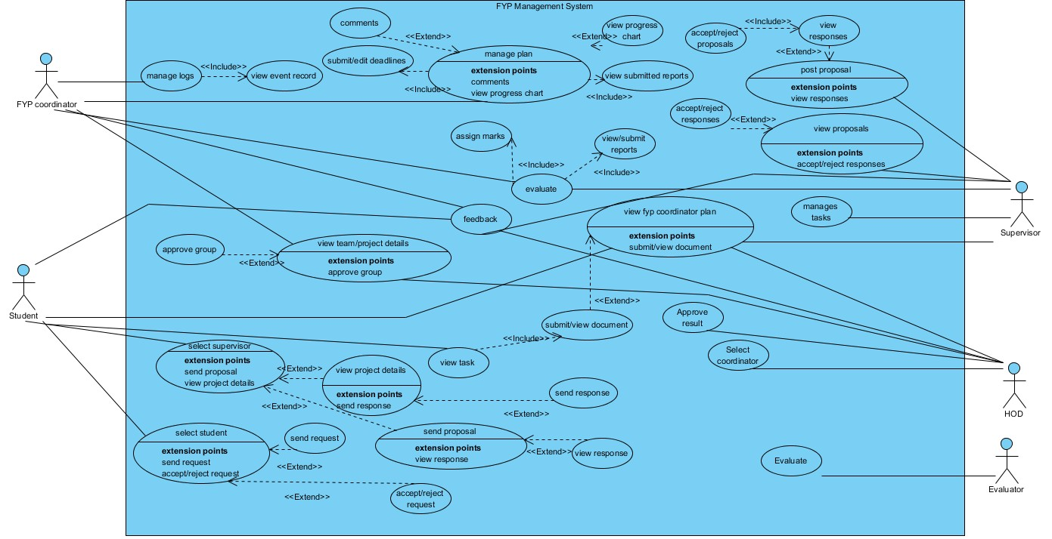

## Functional Requirement

**Submit FYP Ideas UC01:**

**Use Case 1:** Submit FYP Ideas UC01

Actor: Supervisor

Precondition: Supervisor is logged in and has access to the system.

Basic Flow: Supervisor fills in the required FYP idea details.

**Actor Actions:**

1. Supervisor navigates to the FYP Ideas submission page.
2. Supervisor enters the FYP idea details.
3. Supervisor submits the FYP idea.

**System Response:**

* The system saves the FYP idea and notifies the FYP coordinator.

**Alternative Course of Action:**

* If required details are missing, the system prompts the teacher to enter them.

**View Student Response to FYP Idea:**

**Use Case 2:** View Student Response to FYP Idea

Actor: Supervisor

Precondition: Supervisor is logged in and has access to the system.

Basic Flow: Supervisor selects the FYP idea.

**Actor Actions:**

1. Supervisor navigates to the FYP Idea response page.
2. Supervisor selects the FYP idea.

**System Response:**

* The system displays the student responses to the selected FYP idea.

**Alternative Course of Action:**

* If there are no responses, the system displays a message saying "No responses found".

**View Student Proposals:**

**Use Case 3**: View Student Proposals

Actor: Supervisor

Precondition: Supervisor is logged in and has access to the system.

Basic Flow: Supervisor selects a student proposal.

**Actor Actions:**

1. Supervisor navigates to the Student Proposal page.
2. Supervisor selects a student proposal.

**System Response:**

* System displays the list of student proposals.
* The system displays the details of the selected proposal.

**Alternative Course of Action:**

* If there are no proposals, the system displays a message saying "No proposals found".

**Accept/Reject FYP Proposal:**

**Use Case 4: Accept/Reject FYP Proposal UC04**

Actor: Supervisor

Precondition: Supervisor is logged in and has access to the system.

Basic Flow: Supervisor selects a proposal and accepts or rejects it.

**Actor Actions:**

1. Supervisor navigates to the FYP Proposal page.
2. Supervisor selects a proposal.
3. Supervisor accepts or rejects the proposal.

**System Response:**

* System displays the list of FYP proposals.
* System displays the details of the selected proposal.
* The system saves the Supervisors decision and notifies the FYP coordinator, student and HOD.

**Alternative Course of Action:**

* If the proposal is rejected, the system prompts the Supervisor to provide a reason for rejection.

**Make Group:**

**Use Case 5: Make Group**

Actor: FYP Coordinator

Precondition: FYP coordinator is logged in and has access to the system.

Basic Flow: FYP coordinator selects and approves the request of team from supervisor and students to form a team and assigns a team name.

**Actor Actions:**

1. FYP coordinator navigates to the Approve group page.
2. FYP coordinator selects the evaluators of the project for a team.
3. FYP coordinator assigns a team name.

**System Response:**

* The system creates the team and notifies the team members.

**Alternative Course of Action:**

* The Fyp coordinator rejects the proposal to make a team.

**Create Plan:**

**Use Case 6:**

Name: **Create Plan**

Actor: FYP Coordinator

Precondition: The FYP coordinator is logged in and has selected Plan tab

Basic Flow: The FYP Coordinator fills out the plan details form and submits it.

**Actor Actions:**

1. The FYP Coordinator selects the "plans" option from the dashboard.
2. The FYP Coordinator fills out the information required to submit.
3. The FYP Coordinator selects the document and submits it.

**System Response:**

* The system displays a form to fill out the project details such as project title, description, objectives, and expected outcomes.
* The system saves the project details and assigns a project ID to it.
* The system creates a new project and assigns the selected student team to work on it.

**Alternative Course of Actions:**

If the FYP Coordinator decides not to create a project, they can go back to the dashboard without submitting the form.

**Assign Task:**

**Use Case 7:**

Name: Assign Task

Actor: Supervisor

Precondition: The Supervisor is logged in and has access to the project.

Basic Flow: The Supervisor assigns the project task to the group and submits it.

**Actor Actions:**

1. The Supervisor selects the "Tasks " option from the dashboard.
2. The system displays the projects of the supervisor.
3. The Supervisor selects the project of to whom he wants to assign task.
4. The supervisor then assigns the task to the team and submits

**System Response:**

The system displays the list of project tasks assigned to the specific project

The system assigns the tasks.

**Alternative Course of Actions:**

If the Supervisor decides not to edit the plan, they can go back to the dashboard without saving any changes.

**Specify Project Development Phases/Interim:**

**Use Case 9**:

Name: Specify Project Development Phases/Interim

Actor: FYP Coordinator

Precondition: The FYP Coordinator is logged in and has access to the project plan.

Basic Flow: The FYP Coordinator specifies the development phases for the project.

**Actor Actions:**

1. The FYP Coordinator selects the "Interim" option from the dashboard.
2. The FYP Coordinator specifies the development phases for the project.

**System Response:**

* The system displays the project plan.
* The system updates the project plan with the specified development phases.

**Alternative Course of Actions:**

If the FYP Coordinator decides not to specify the development phases, they can go back to the dashboard without saving any changes.

**View Reports:**

**Use Case 11:**

Name: View Reports

Actor: FYP Coordinator

Precondition: The FYP coordinator must be logged in to the system and must have the required access rights.

Basic Flow: The FYP coordinator selects a report to view.

**Actor Actions:**

1. The FYP coordinator selects the "View Reports" option from the dashboard.
2. The FYP coordinator selects a report to view.

**System Response:**

* The system displays a list of reports available to the FYP coordinator.
* The system displays the selected report to the FYP coordinator.

**Alternative Course of Actions:** None.

**Submit Reports:**

**Use Case 12:**

Name: Submit Reports

Actor: FYP Coordinator

Precondition: The FYP coordinator must be logged in to the system and must have the required access rights.

Basic Flow: The FYP coordinator selects a report to submit and confirms the submission

**Actor Actions:**

1. The FYP coordinator selects the "Submit Reports" option from the dashboard.
2. The FYP coordinator selects a report to submit.
3. The FYP coordinator confirms the submission.

**System Response:**

* The system displays a list of reports available to the FYP coordinator for submission.
* The system prompts the FYP coordinator to confirm the submission.
* The system confirms the successful submission of the report.

**Alternative Course of Actions:**

If the FYP coordinator cancels the submission, the report is not submitted and the system returns to the previous screen.

**Assign Evaluators:**

**Use Case 13:**

Name: Assign Evaluators

Actor: HOD

Precondition: The FYP Coordinator must be logged in to the system and must have the required access rights.

Basic Flow: The FYP Coordinator selects one or more evaluators from the list and assigns them to a specific FYP project.

**Actor Actions:**

1. The FYP Coordinator selects the "Assign Evaluators" option from the dashboard.
2. The FYP Coordinator selects one or more evaluators from the list.
3. The FYP Coordinator assigns the selected evaluators to a specific FYP project.

**System Response:**

* The system displays a list of available evaluators.
* The system confirms the successful assignment of FYP Coordinator to the FYP project.

**Alternative Course of Actions:** None.

**Assign FYP Coordinator:**

**Use Case 13:**

Name: Assign FYP Coordinator

Actor: HOD

Precondition: The HOD must be logged in to the system and must have the required access rights.

Basic Flow: The HOD selects one FYP Coordinator from the list and assigns him to the FYP Management System

**Actor Actions:**

1. The HOD selects the Users from the Dashboard.
2. The HOD selects the "Assign FYP Coordinator " option from the Users.
3. The HOD selects one list.
4. The HOD assigns the selected FYP Coordinator to the entire FYP management system.

**System Response:**

* The system displays a list of available FYP Coordinators.
* The system confirms the successful assignment of FYP Coordinator to the System.

**Alternative Course of Actions:** None

**Send/Receive Notifications:**

**Use Case 14:**

Name: Send/Receive Notifications

Actor: FYP Coordinator

Precondition: The FYP coordinator must be logged in to the system and must have the required access rights.

Basic Flow: The FYP coordinator selects the desired notification type, enters the notification message, and sends the notification.

**Actor Actions:**

1. The FYP coordinator selects the "Send/Receive Notifications" option from the dashboard.
2. The system displays a list of notification types (students, FYP coordinators, HOD, supervisor).
3. The FYP coordinator selects the desired notification type.
4. The system prompts the FYP coordinator to enter the notification message.
5. The FYP coordinator enters the notification message.
6. The FYP coordinator sends the notification.

**System Response:**

* The system displays a list of notification types (students, FYP coordinators, HOD, supervisor).
* The system prompts the FYP coordinator to enter the notification message.
* The system confirms the successful sending of the notification.

**Alternative Course of Actions:** None.

**Send and Receive Evaluation Reports**

**Use Case 15:**

Name: Send and Receive Evaluation Reports

Actor: FYP Coordinator, Supervisor, Evaluator

Precondition: The evaluation reports must be ready and available for the relevant stakeholders.

Basic Flow: FYP Coordinator: Sends evaluation reports to the Supervisor and the Evaluator.

Supervisor and Evaluator: Receives and review evaluation reports, provides feedback to the FYP Coordinator

Actor Actions:

1. The FYP Coordinator sends the evaluation reports to the Supervisor and the Evaluator.
2. The Supervisor and the Evaluator receive the evaluation reports.
3. The Supervisor and the Evaluator review the evaluation reports.
4. The Supervisor and the Evaluator provide feedback on the evaluation reports to the FYP Coordinator.

System Response:

* The system sends the evaluation reports to the Supervisor and the Evaluator.
* The system receives feedback on the evaluation reports from the Supervisor and the Evaluator.

Alternative Course of Actions:

* If the evaluation reports are not ready, the FYP Coordinator cannot send them to the Supervisor and the Evaluator.

## Interface Requirements

The FYP Management System should meet the following interface requirements:

1. User Interface: The FYP Management System should have a user-friendly interface that caters to the needs of various user roles involved in the FYP process. The interface should be intuitive and easy to navigate, ensuring a positive user experience. The following interface requirements are derived from the specific needs outlined in the scenario:
2. Dashboard: Each user role (HOD, Coordinator, Supervisor, Student, and Evaluator) should have a dedicated dashboard that provides a personalized view of relevant information and actions. The dashboard should display important notifications, task statuses, and project details in a clear and organized manner.
3. Project Listing: Students should be able to view a list of available supervisors, including their project ideas, along with the option to submit their interest. Supervisors should have access to a list of students who have submitted their responses. The interface should facilitate easy filtering, searching, and sorting of projects and associated details.
4. Proposal Management: Students should be able to submit project proposals to their selected supervisors through a user-friendly form. Supervisors should have the ability to review and accept/reject these proposals within the system. The interface should allow supervisors to provide feedback or comments on the proposals.
5. Task Management: Supervisors should be able to create and assign tasks to the students in their groups. The interface should provide an intuitive form for defining task details, including deadlines, descriptions, and any required documents. Students should be able to view and track their assigned tasks, submit progress reports, and receive notifications for upcoming deadlines.
6. Project Plan Display: Coordinators should be able to create project plans with deadlines, descriptions, and document requirements. The interface should present these plans to the respective project groups, allowing students to view and submit the requested documents within the defined timelines.
7. Document Evaluation: Evaluators should have access to the submitted documents for evaluation. The interface should provide a clear and standardized evaluation form that allows evaluators to assess the submitted work and provide feedback or scores.
8. Physical Interface: The system should be accessible through web browsers on various devices, such as desktop computers, laptops, tablets, and mobile phones, ensuring compatibility and responsiveness.
9. Software/Component Interface: The system should integrate with external components, such as the database server and authentication systems, ensuring smooth and secure communication between the system and these components.

## Database Requirements

The FYP Management System should meet the following database requirements:

1. Data Storage: The system should provide a robust and scalable database to store user information, project details, task data, document submissions, and evaluation results.
2. Data Integrity: The database should ensure the integrity and consistency of data, allowing secure and reliable storage and retrieval of information.
3. Data Security: The system should implement appropriate security measures, such as encryption and access control, to protect the confidentiality and integrity of the stored data.

## Non-Functional Requirements

3.5.1 Security

1. The FYP Management System should implement robust security measures to safeguard user data and prevent unauthorized access.
2. User authentication and authorization mechanisms should be in place to ensure that only authorized individuals can access and modify the system.
3. Data encryption should be used to protect sensitive information during storage and transmission.
4. The system should adhere to industry-standard security practices to mitigate the risk of data breaches or security vulnerabilities.

3.5.2 Performance

1. The system should be capable of handling concurrent user requests efficiently, ensuring optimal performance even during peak usage periods.
2. Response times for user interactions, such as submitting proposals, accessing tasks, and viewing documents, should be minimized to provide a seamless user experience.
3. The system should be scalable to accommodate an increasing number of users and data without compromising performance.

3.5.3 Usability

The user interface of the system should be intuitive, user-friendly, and aesthetically pleasing to facilitate ease of use for all types of users.

Clear and concise instructions should be provided to guide users through the different functionalities and processes of the system.

The system should provide helpful notifications, error messages, and feedback to assist users in their interactions and avoid confusion or frustration.

3.5.4 Modifiability

1. The system should be designed in a modular and extensible manner to facilitate future enhancements, modifications, and customization.
2. Changes to business rules, user roles, or system workflows should be accommodated without significant disruptions or code restructuring.
3. The use of well-documented and maintainable code practices should be employed to simplify future modifications.

3.5.5 Reliability/Availability

1. The system should have a high level of reliability, ensuring that it is available to users consistently without unplanned downtime or disruptions.
2. Adequate backup and recovery mechanisms should be in place to safeguard against data loss and enable system restoration in case of failure.
3. The system should be resilient to handle unforeseen events, such as power outages or server failures, to minimize service interruptions.

3.5.6 Interoperability

1. The FYP Management System should be designed to seamlessly integrate with existing university systems, such as student databases and authentication systems.
2. The system should support interoperability with external services or APIs that may be required for additional functionalities or data exchange

## Project Feasibility

3.6.1 Technical Feasibility

1. The proposed system should leverage technologies and tools that are readily available and suitable for developing a web application.
2. The technical infrastructure required for hosting, database management, and system maintenance should be feasible and within the capabilities of the university.

3.6.2 Operational Feasibility

1. The system should align with the operational requirements and processes of the university's FYP management.
2. Sufficient resources, including personnel, training, and support, should be available to ensure smooth operations and maintenance of the system.

3.6.3 Legal & Ethical Feasibility

1. The system should comply with relevant legal and regulatory requirements, including data protection and privacy laws.
2. Ethical considerations, such as ensuring fairness in project evaluation and maintaining the confidentiality of sensitive information, should be incorporated into the system's design and operation.

## Analysis Models

[Present any analysis models to present important actors, workflows/business process using activity diagrams, flowcharts, sequence diagram, DFD etc.]

## Conclusion

In conclusion, the system requirements analysis for the FYP Management System has provided a comprehensive understanding of the functional and non-functional aspects that need to be considered for its successful implementation. The functional requirements outline the core functionalities, such as student registration, supervisor selection, task management, project plan creation, and document evaluation. These requirements ensure that the system can effectively support the management of final year projects in an organized and efficient manner.

The interface requirements emphasize the importance of a user-friendly interface that is intuitive and accessible across various devices. It is crucial to provide a seamless user experience for all user roles, allowing them to navigate the system effortlessly and perform their respective tasks.

The non-functional requirements address critical aspects such as security, performance, usability, modifiability, reliability/availability, and interoperability. These requirements ensure that the system meets the expected standards in terms of data protection, system performance, ease of use, adaptability to future changes, reliability, and integration with external components.

Lastly, the project feasibility analysis examines the technical feasibility, operational feasibility, and legal & ethical feasibility of implementing the system. These considerations ensure that the proposed system aligns with the technical capabilities and operational requirements of the university, while also adhering to legal and ethical considerations.

By fulfilling these system requirements, the FYP Management System will provide an efficient and reliable platform for managing the entire lifecycle of final year projects, benefiting students, supervisors, coordinators, evaluators, and the HOD.

# 

System Design

[Present system design in detail covering the following aspects in appropriate sections. Design artefacts will depend on the nature of your project and development approach. Please refer to your supervisor for further guidance.]

## Design Approach

[Your text for this section.]

## System Architecture

FYP Management System is web application which is following 3-tier architecture.

## Logical Design

**4.3.1 Domain Model:**

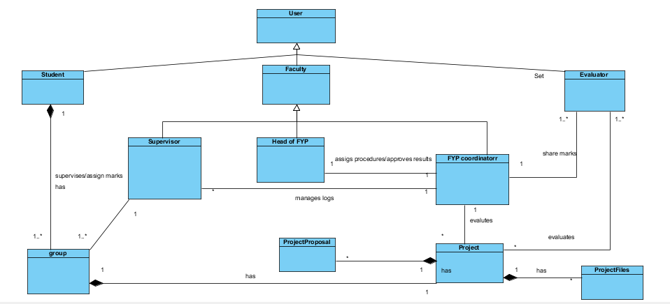

**4.3.2 Class Diagram:**

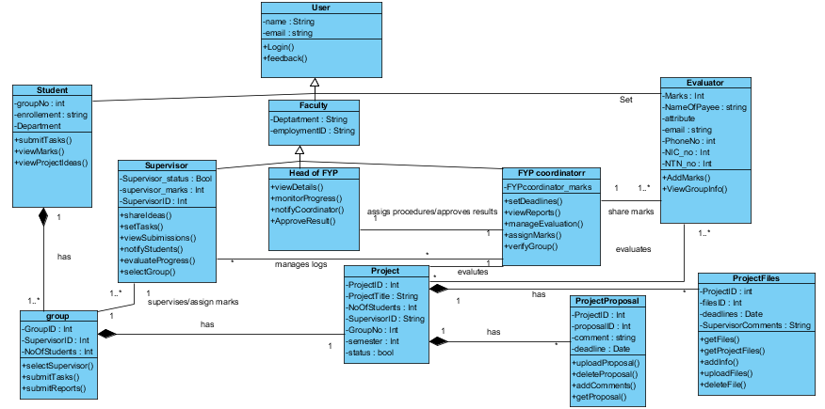

## Dynamic View

* + 1. **Sequence Diagram**

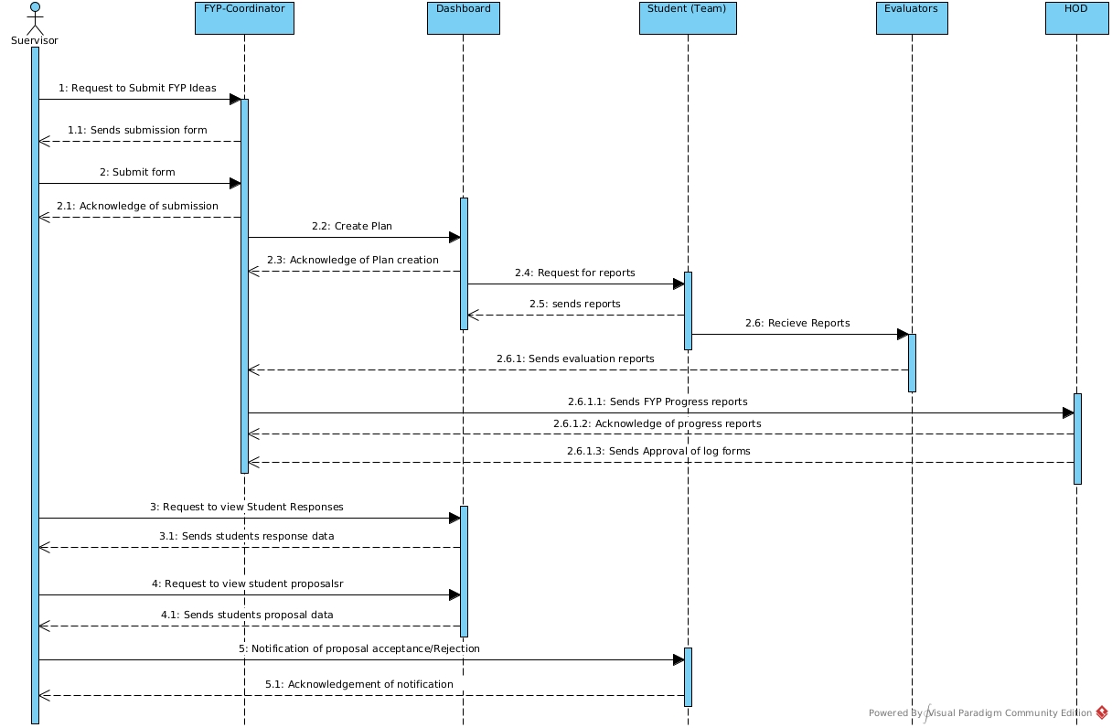

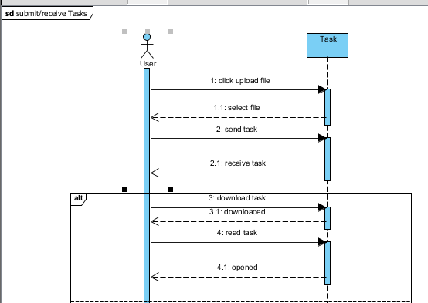

## Component Design

**DEPLOYMENT DIAGRAM:**

A deployment diagram is a sort of UML diagram that depicts system architecture, such as computer hardware and software environments, as well as the middleware that connects them.

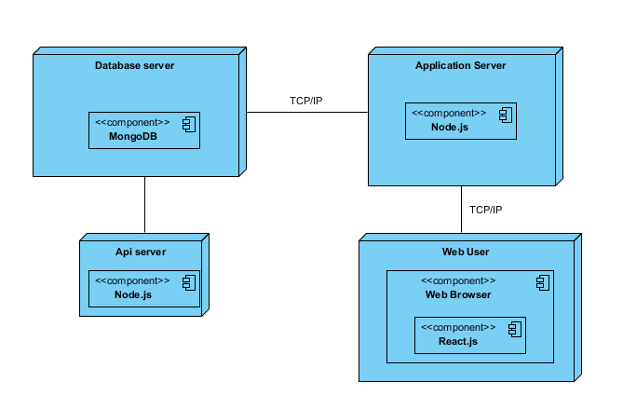

## Data Models

Data models define the structure, fraud, and integrity aspects of data stored in data management systems as related websites.

### ER Diagram

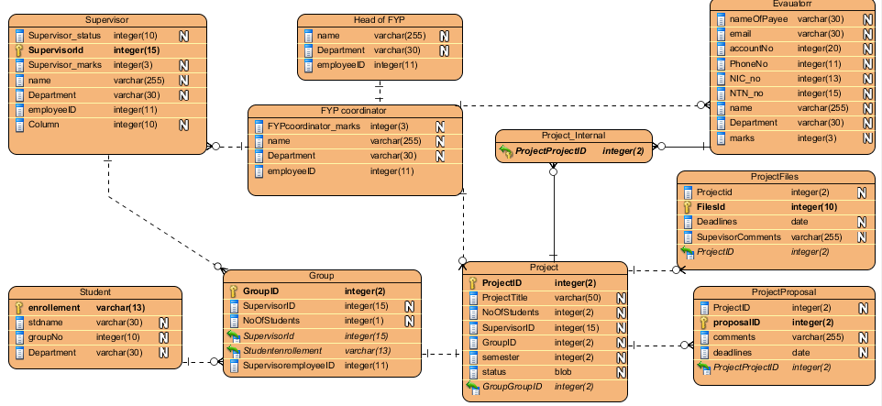

## User Interface Design

**HOD (dashboards)**

Can register coordinator

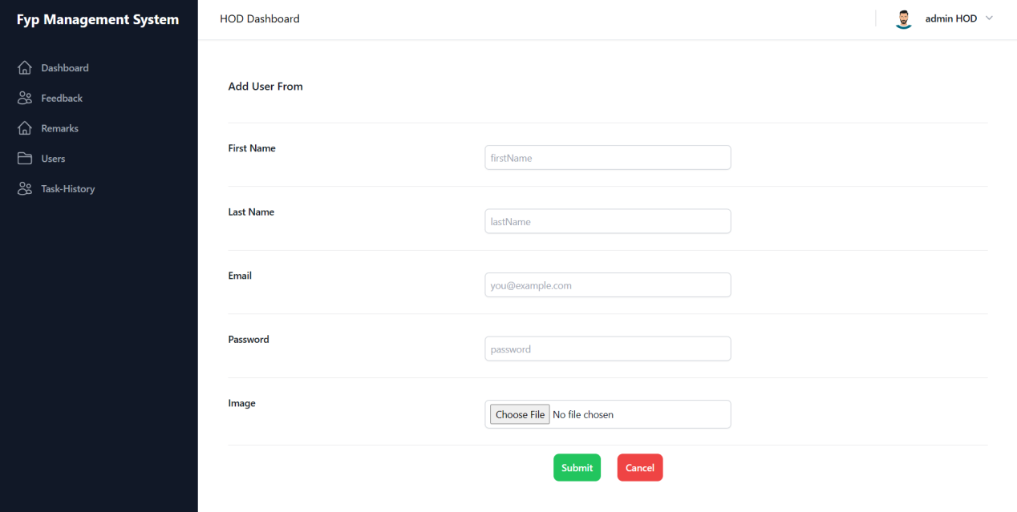

Can view coordinator plans and can add remarks

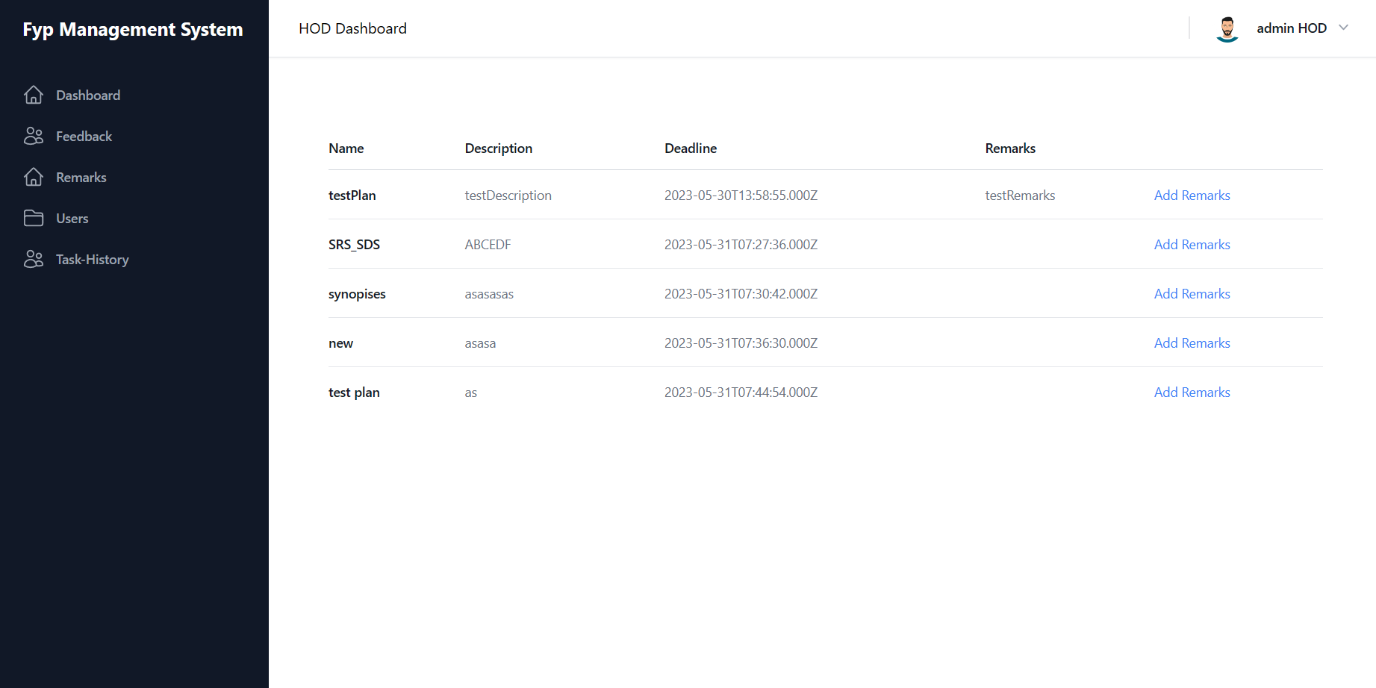

Can view supervisors and student’s task history

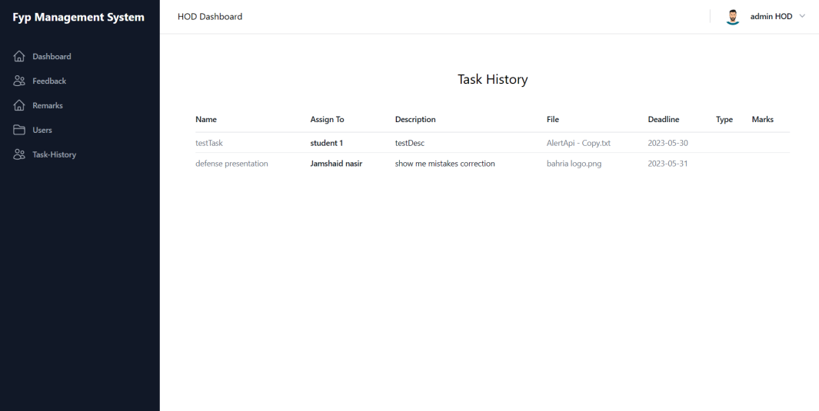

Can view users

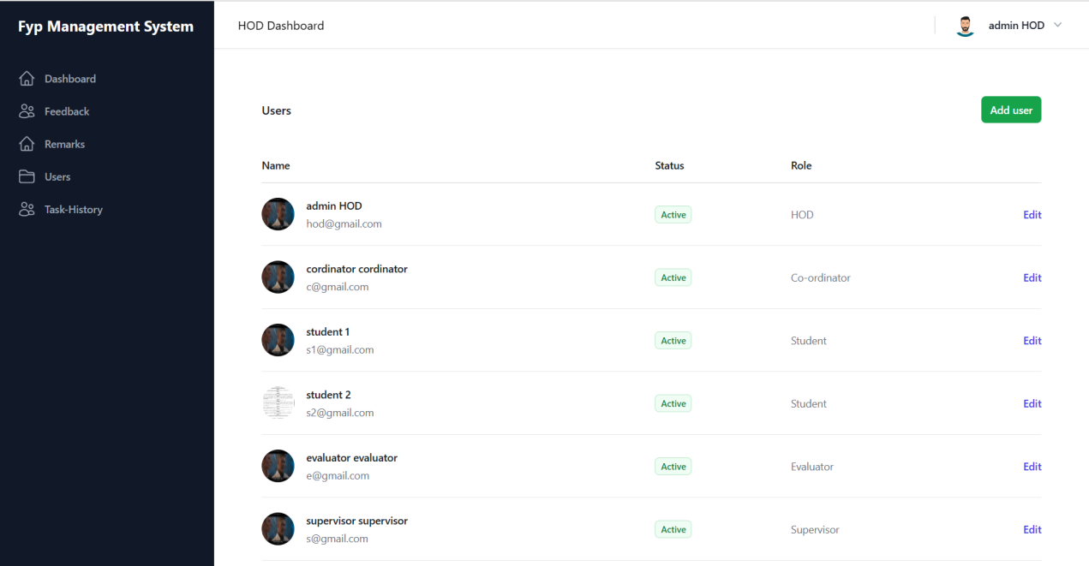

View Feedback

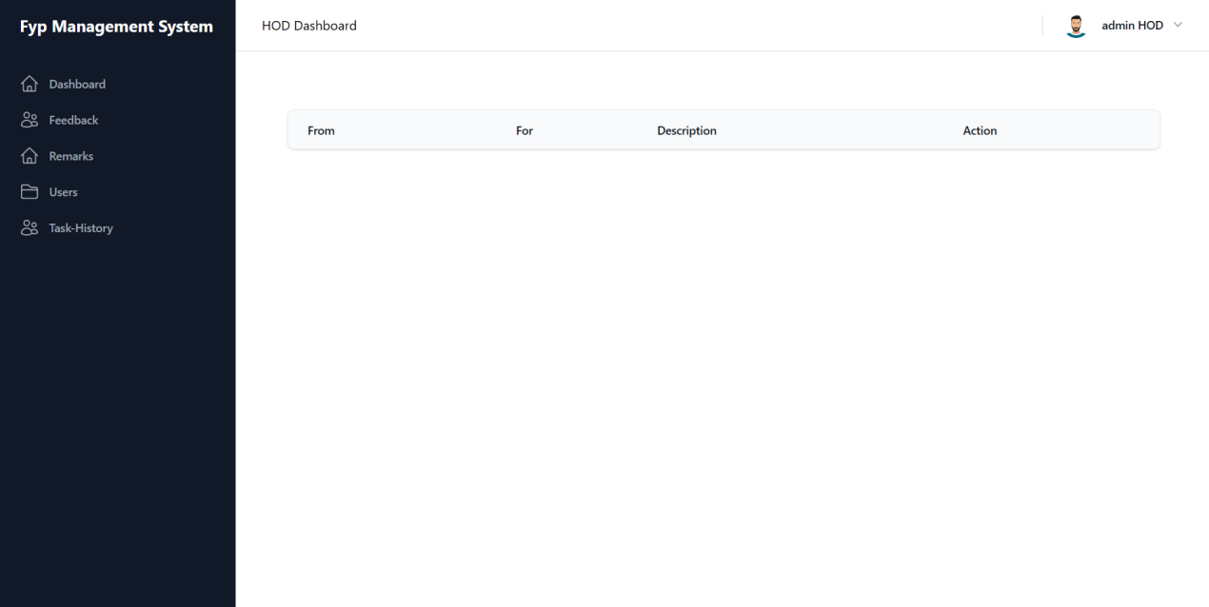

View project details

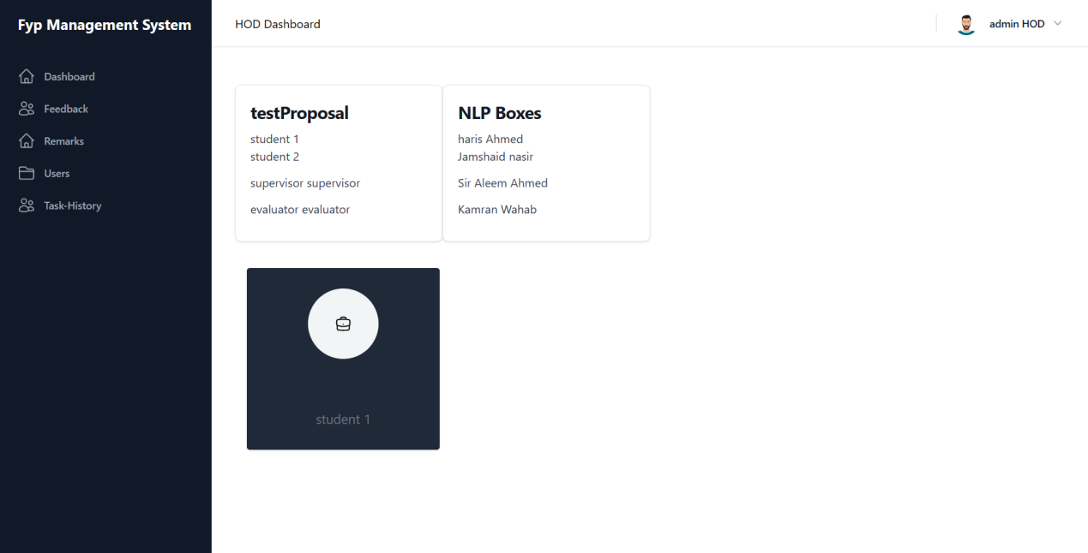

COORDINATOR’S DASHBOARD

Can assign evaluators

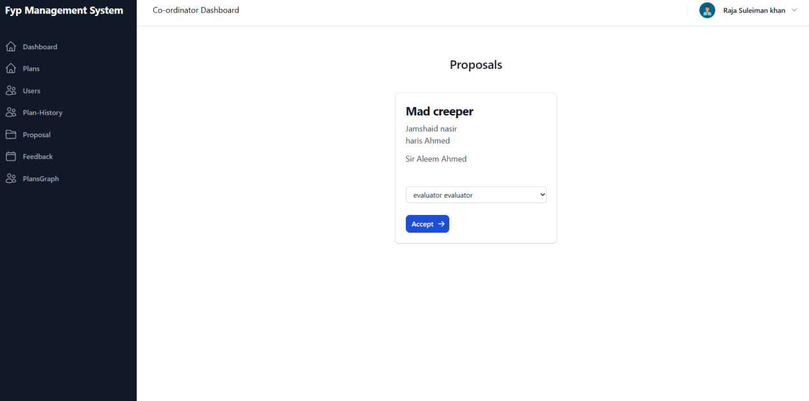

Can create and plan and can decide interim (1,2,final)

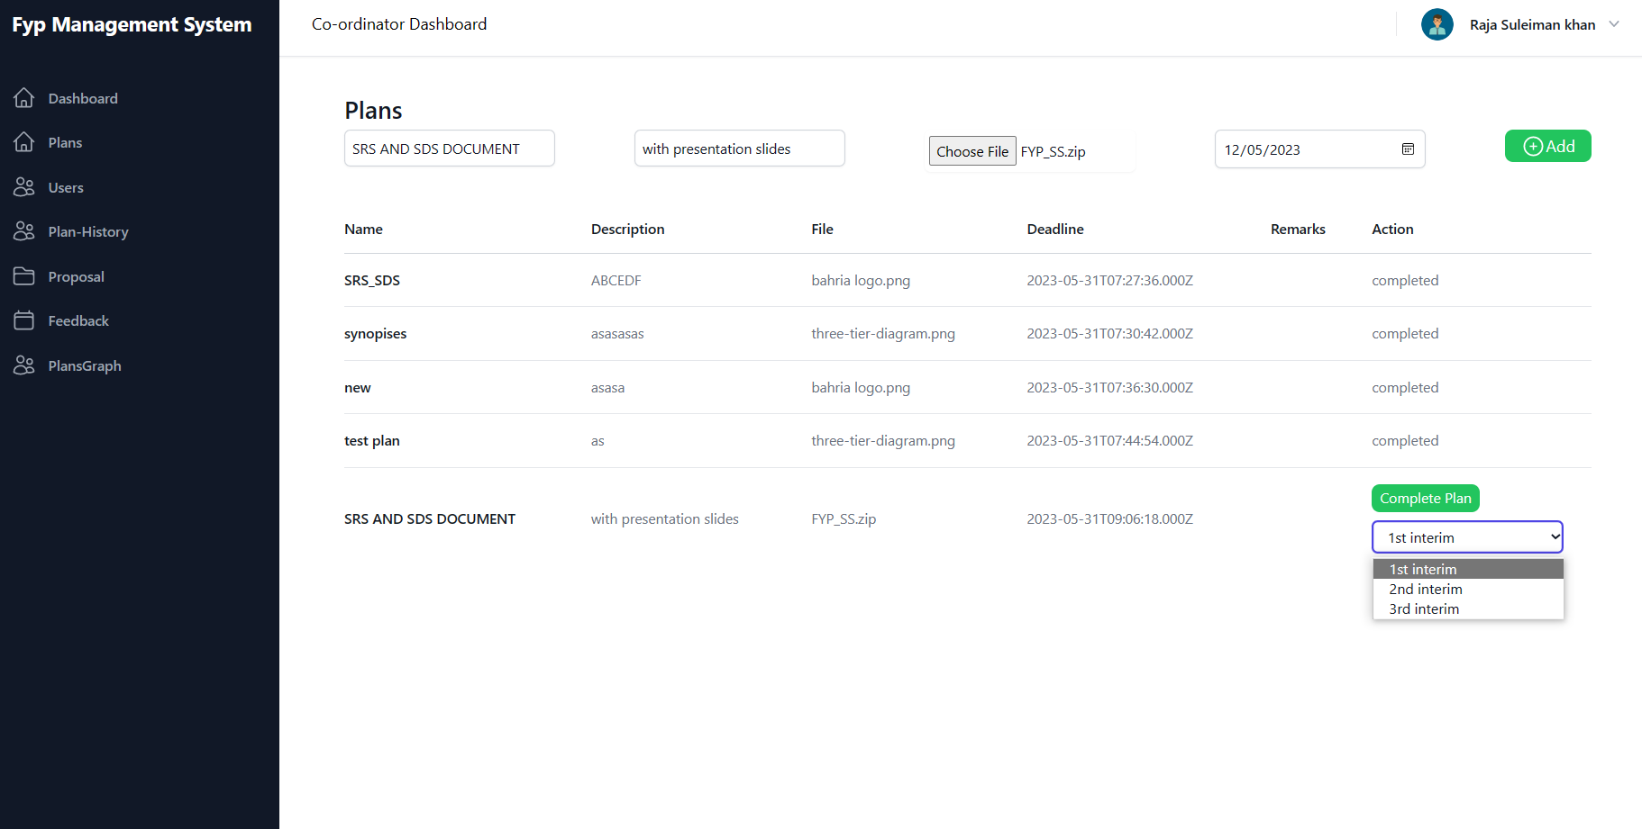

Register users

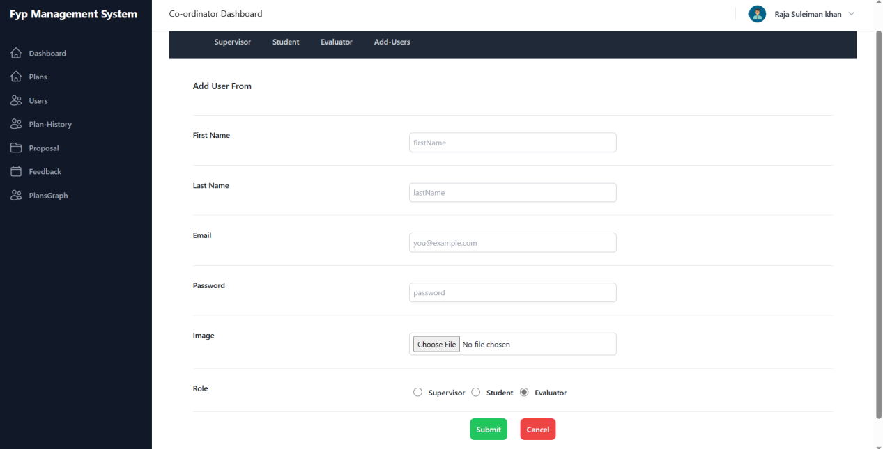

View plans submissions on bar graph

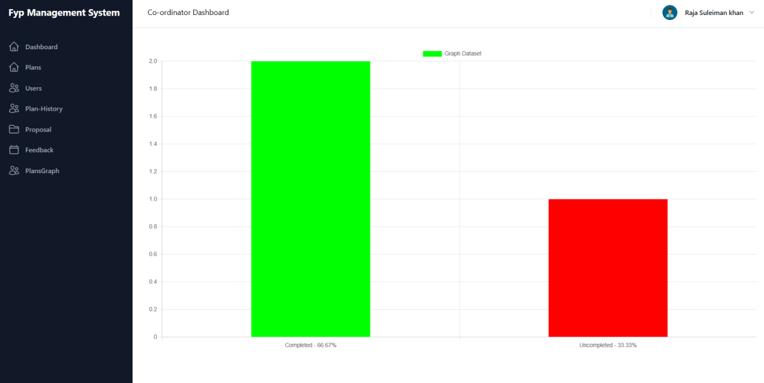

View task history of student and supervisors

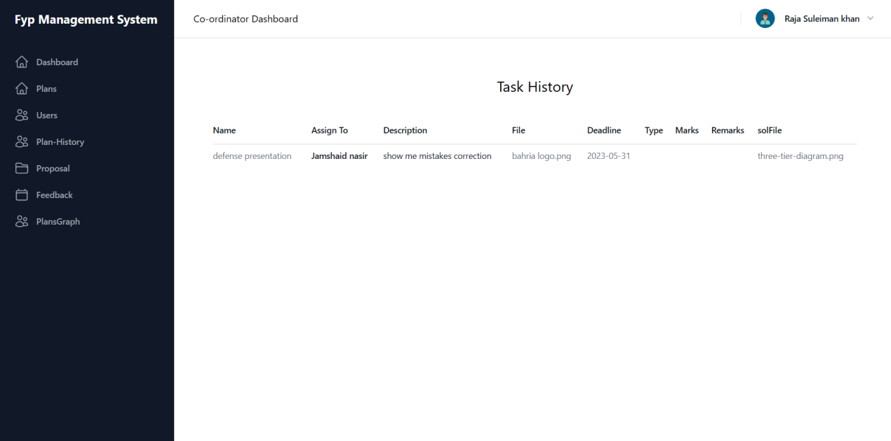

View users

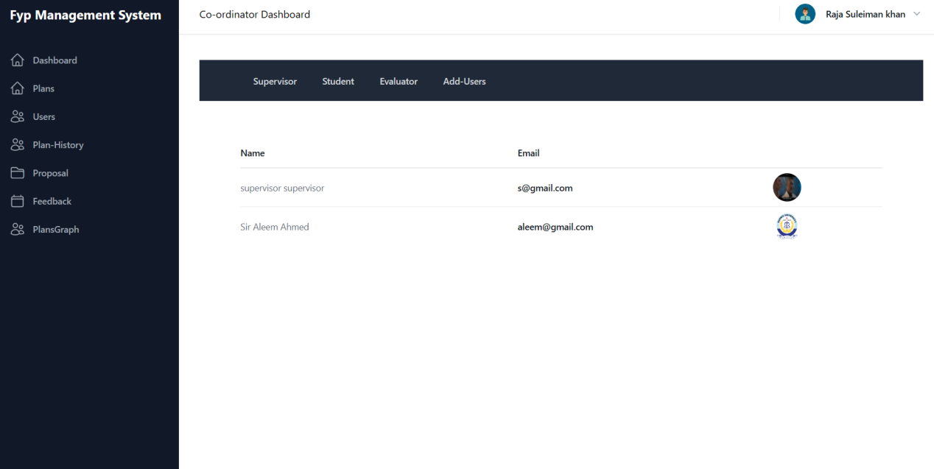

View submissions on students plan

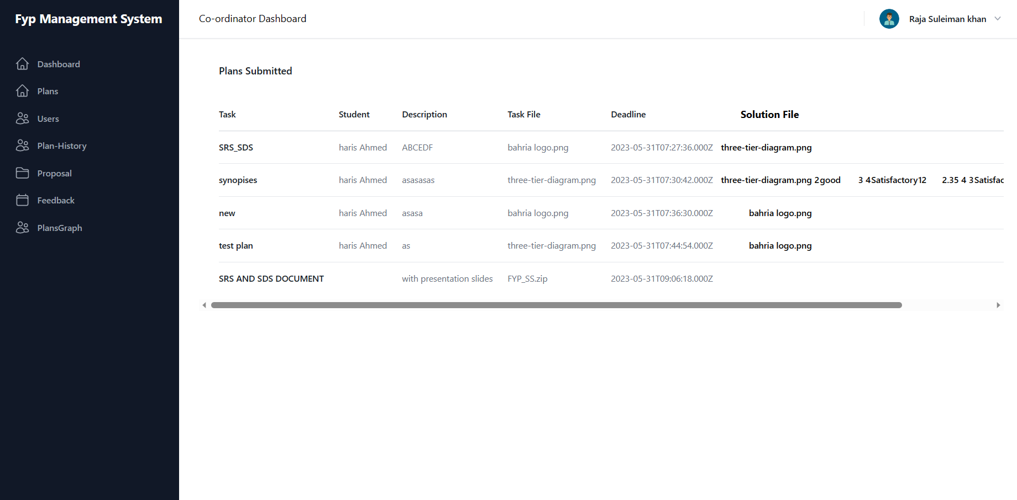

View project details

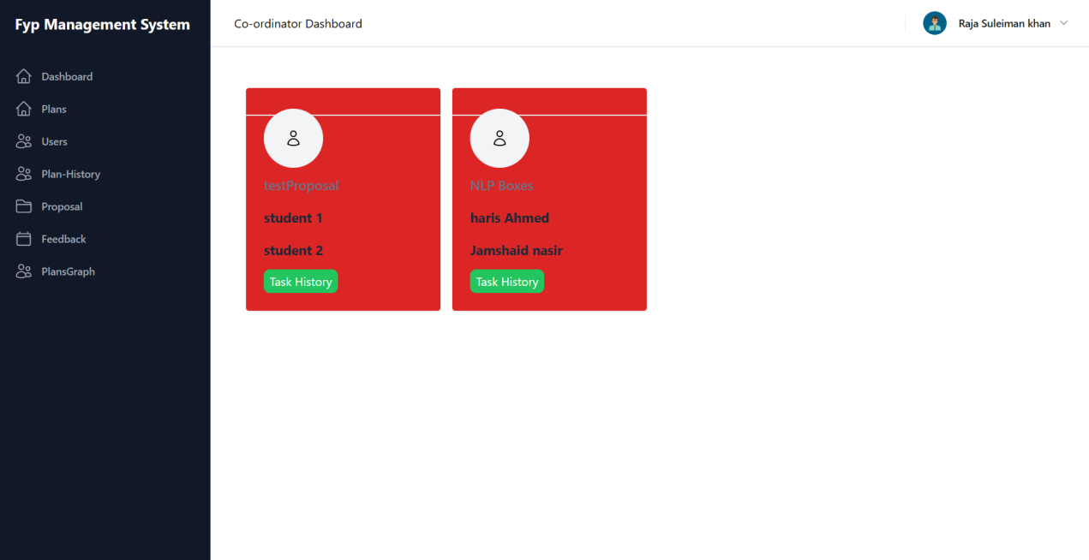

Supervisor’s dashboard:

Accecpt / reject students proposals

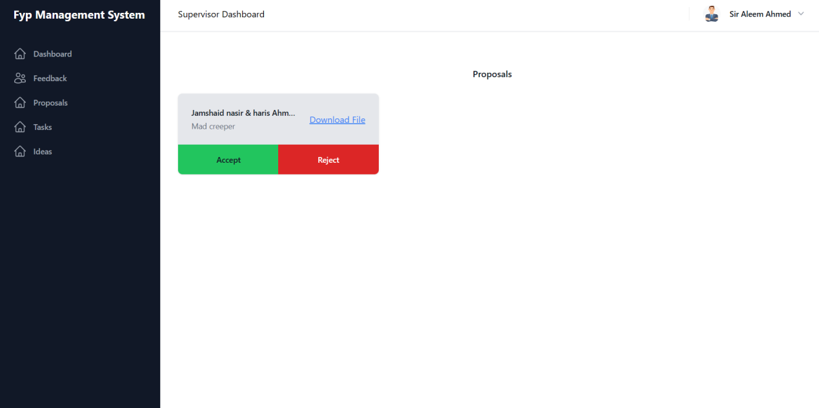

Can submit idea

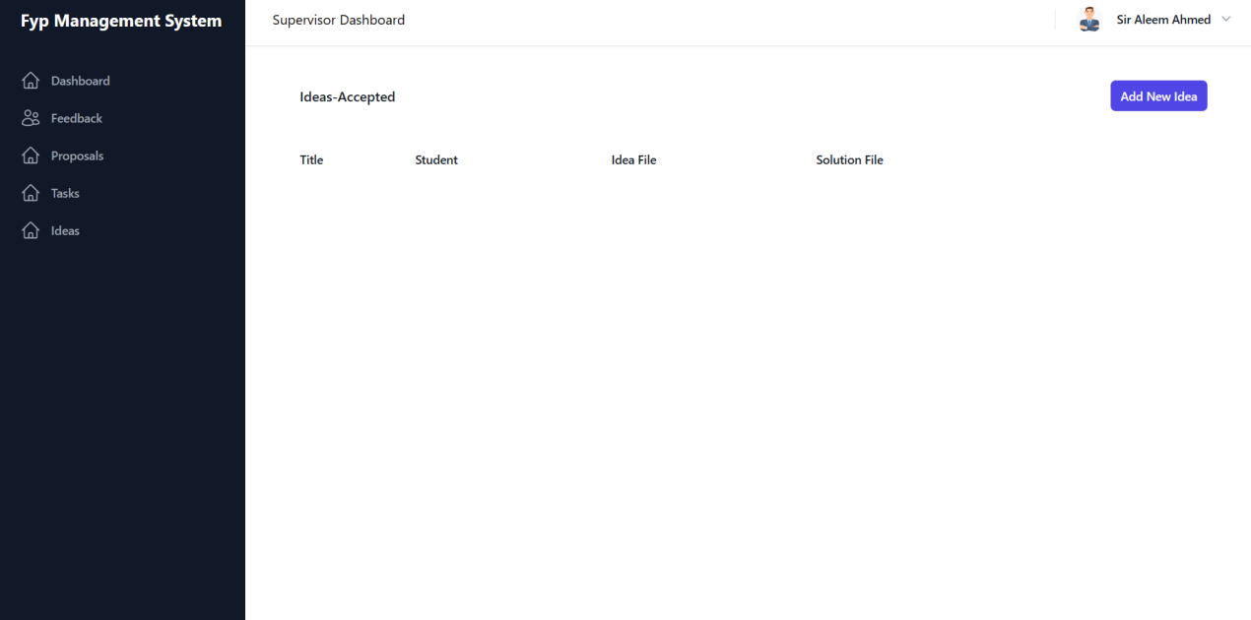

Can assign task

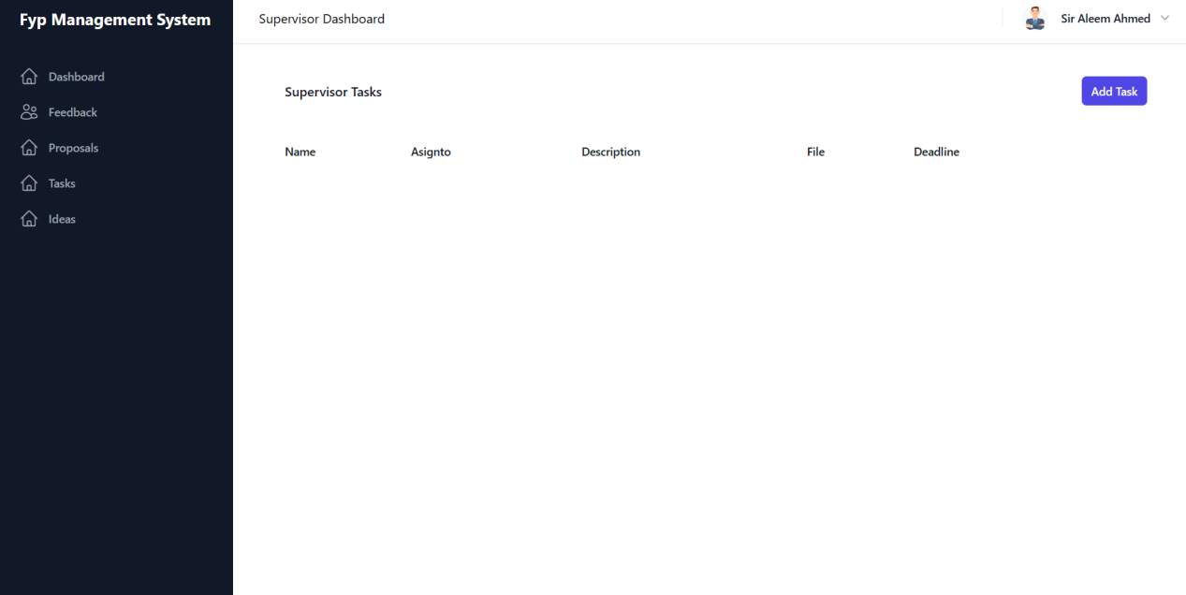

Add feedback

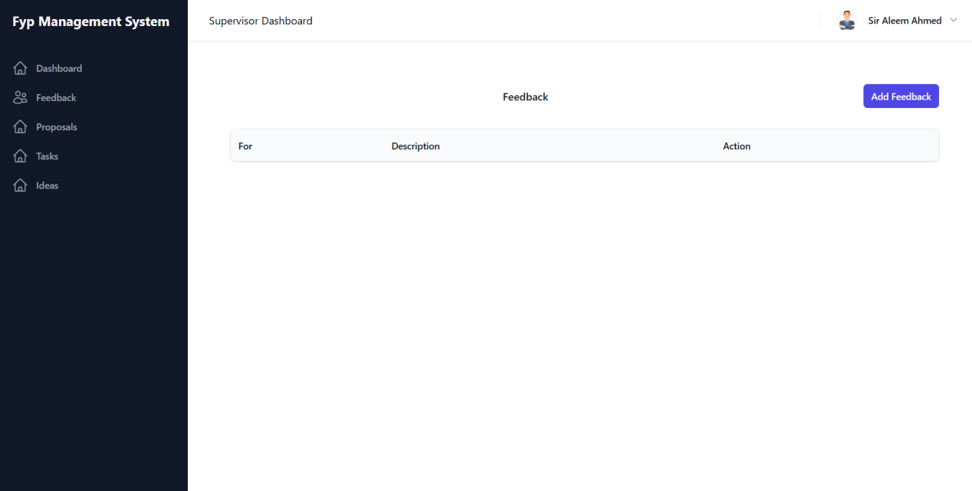

Task assigning to specific group member

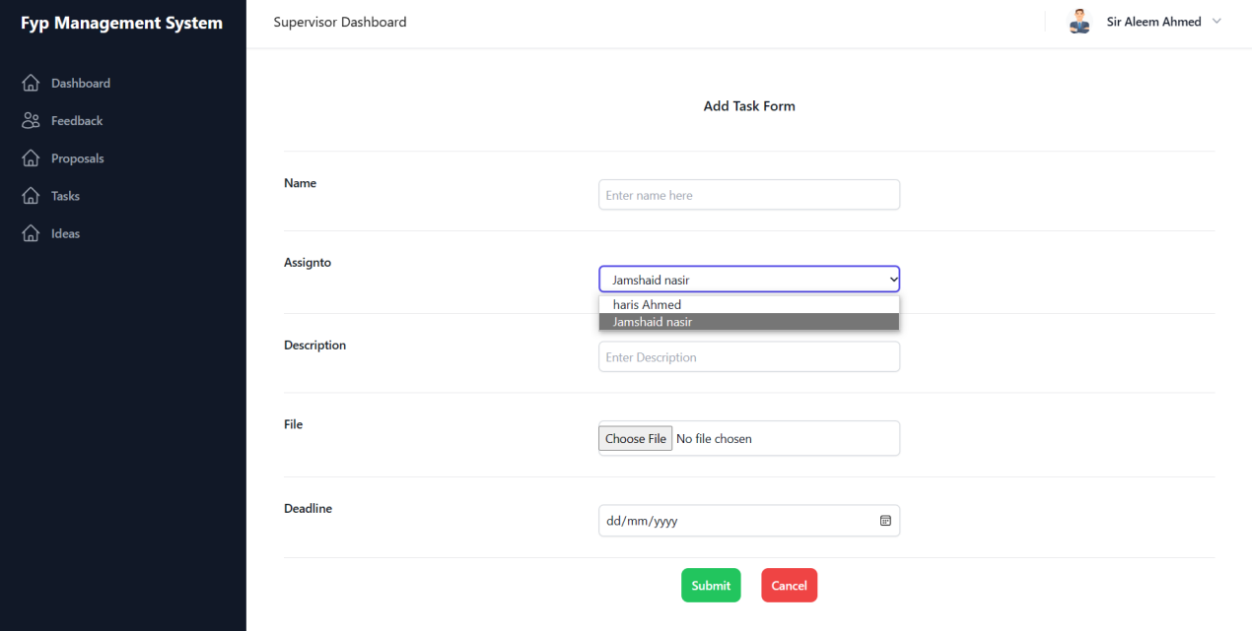

Main dashboard

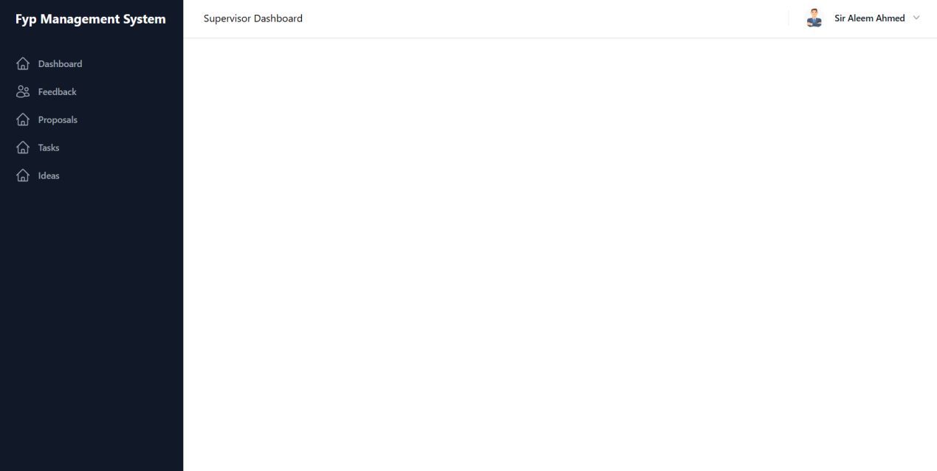

Student’s Dashboard:

Can send proposal

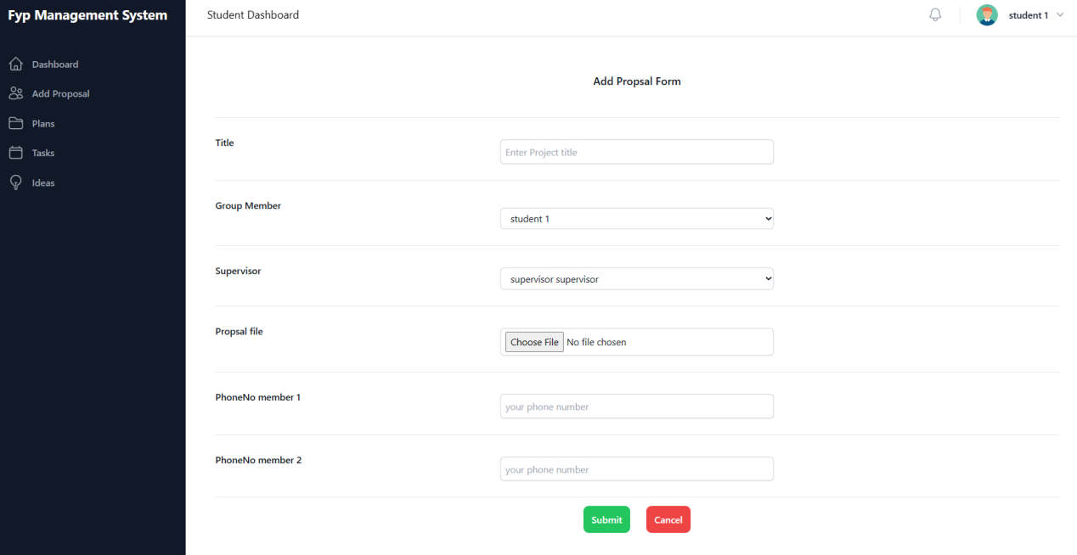

Submission on tasks (supervisor)

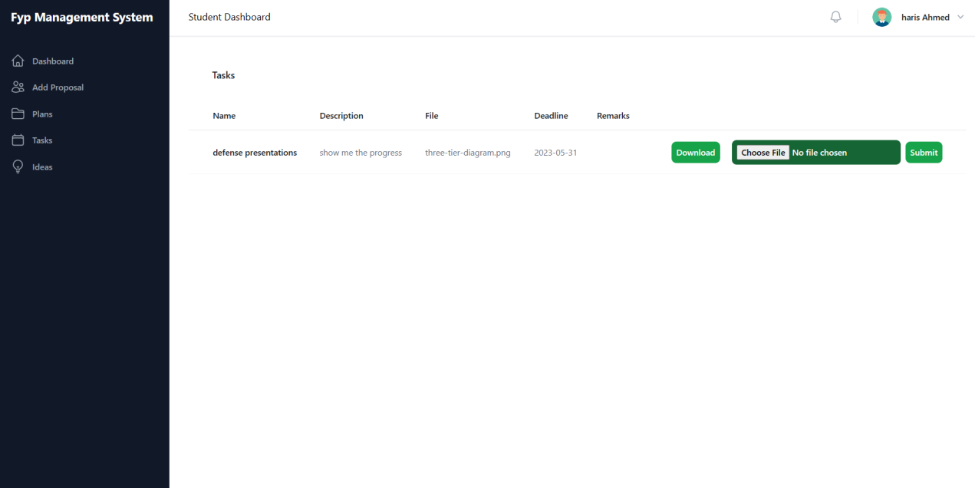

Submit response on supervisor’s idea

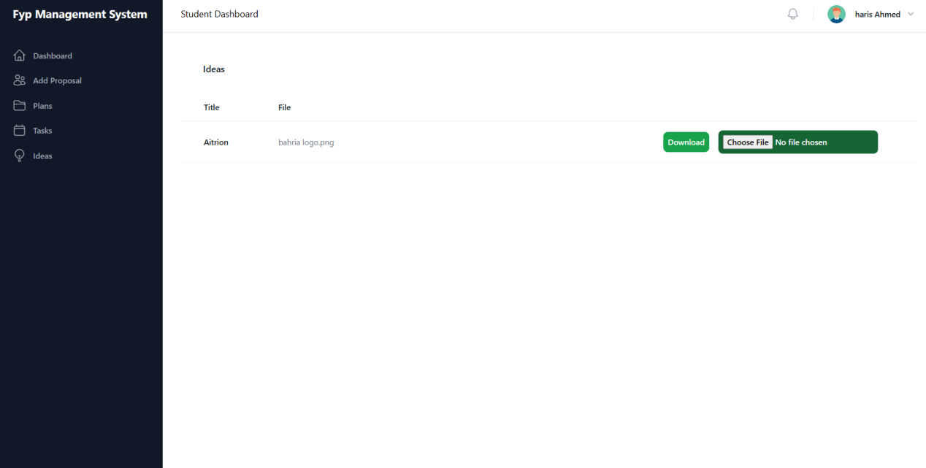

View coordiators’s plan

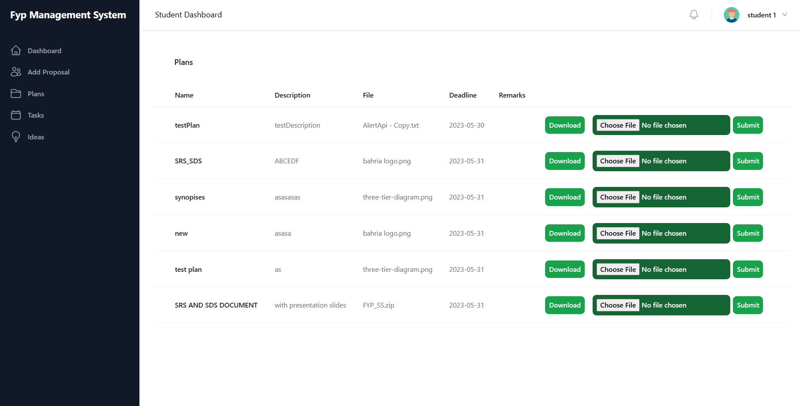

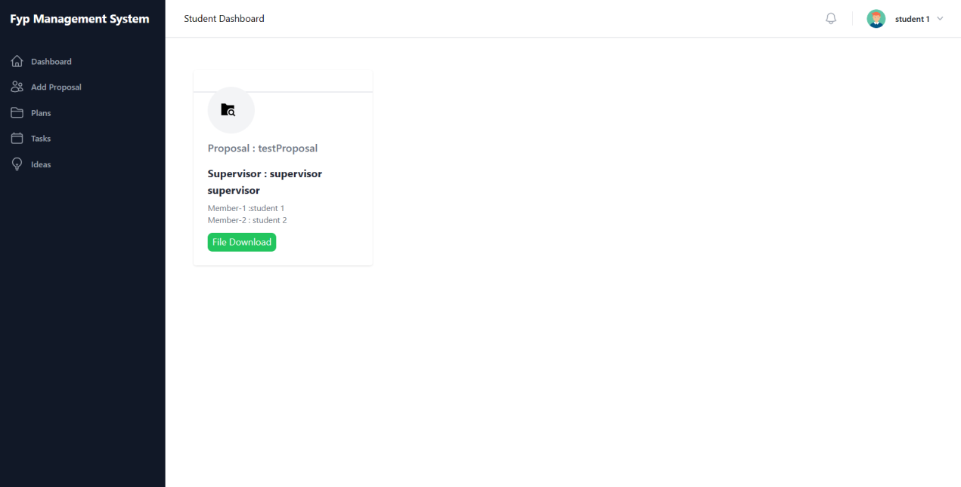

Evaluator’s dashboard;

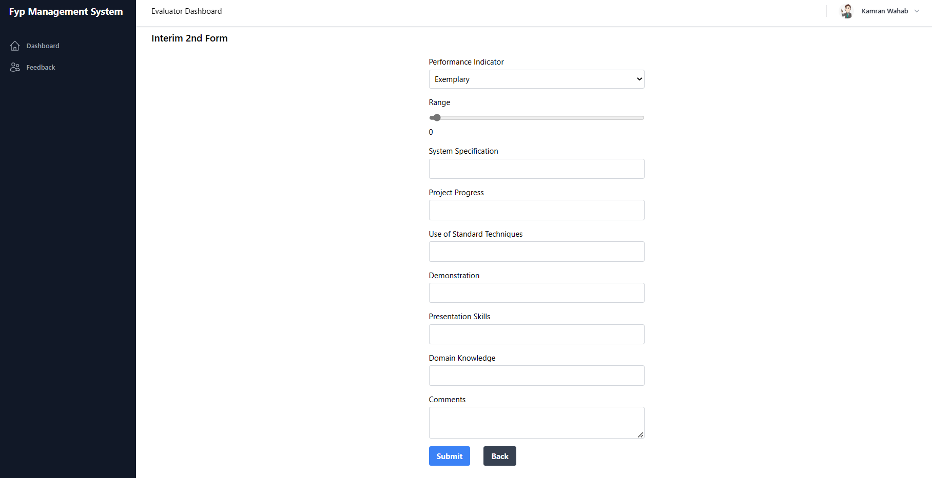

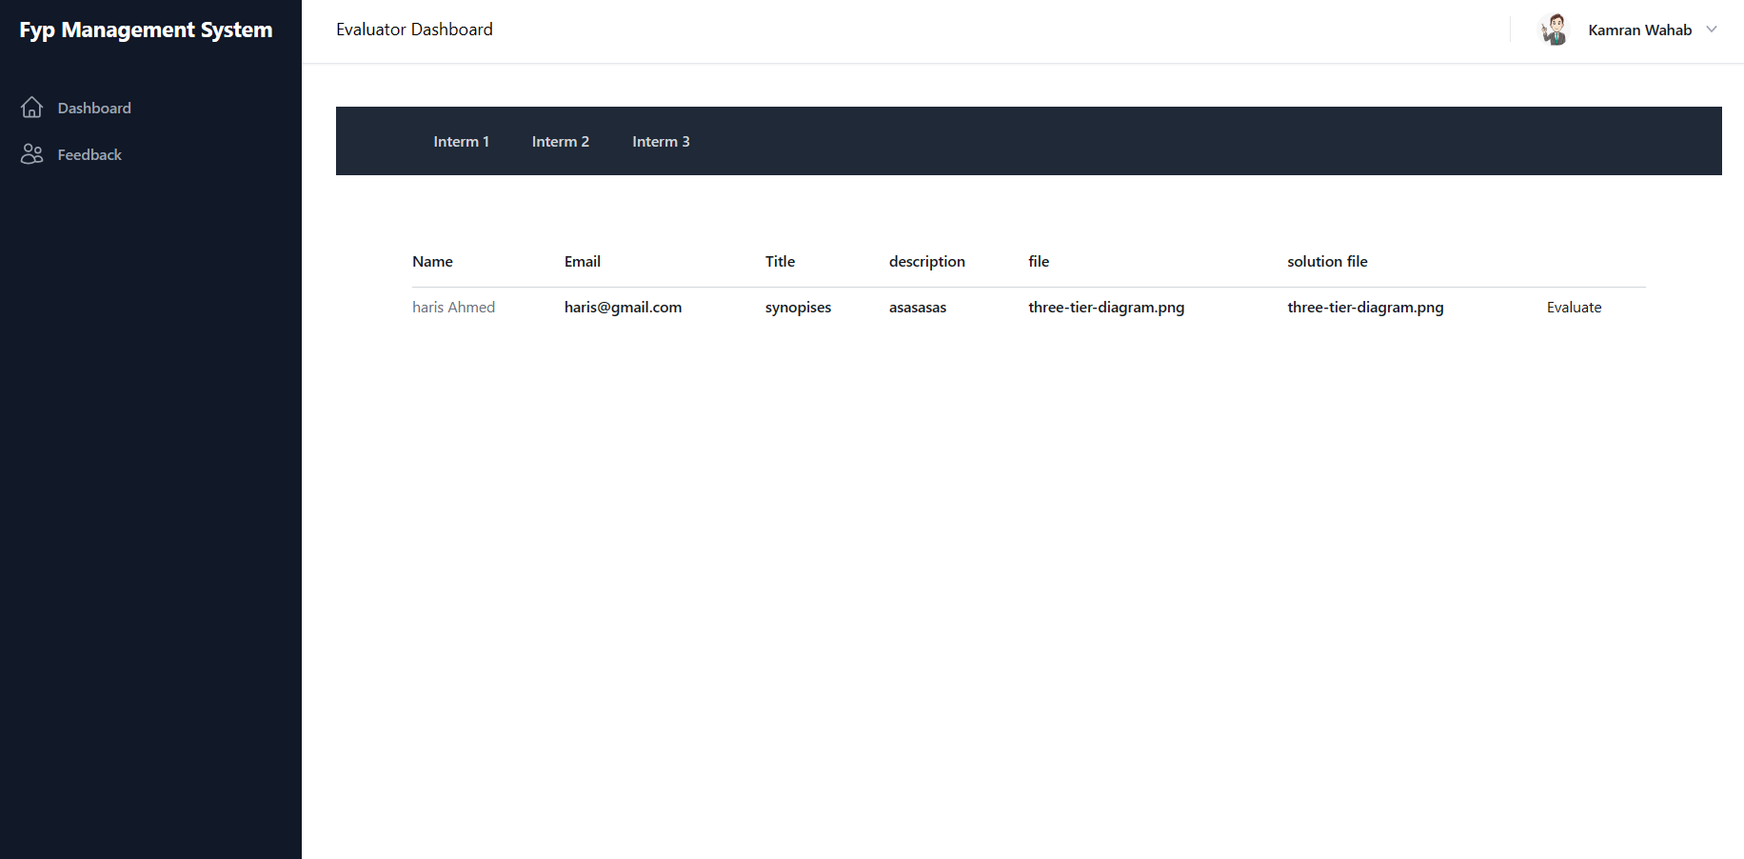

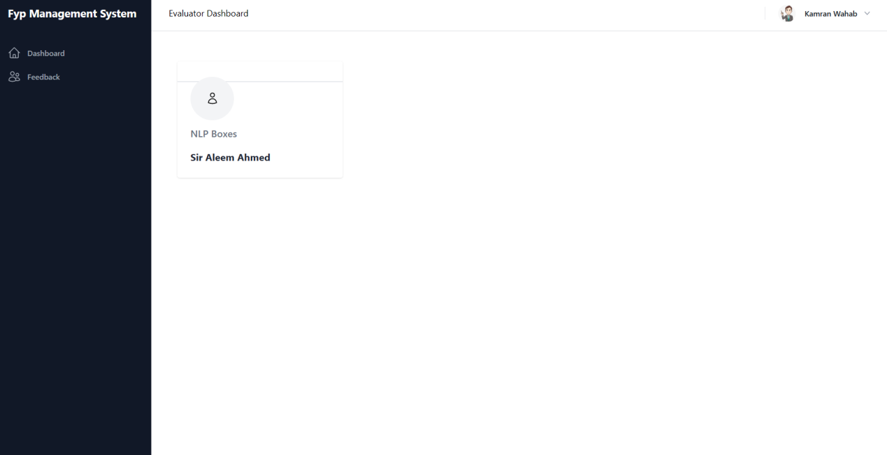

## System Prototype

[Description of system prototypes created (either low-fidelity or high fidelity prototypes. This section can be covered in the User Interface design as well in case of low-fidelity prototyping used. Consult your supervisor for further details].

## Conclusion

[Conclude your chapter here].

# 

System Implementation

In this section, we provide a comprehensive overview of the implementation process of our web application developed using the MERN stack (MongoDB, Express.js, React.js, and Node.js). We discuss the tools and technologies utilized, the development process followed, and the detailed implementation aspects of key features. This includes insights into the data structures, algorithms, and the implementation of essential workflows and processes that contribute to the success of our web application.

## Section

In this section, we delve into the specific details of how our web application was implemented and present the results achieved. We begin by explaining the rationale behind our technology stack choice, highlighting the advantages of MongoDB for the database, Express.js for the server-side framework, React.js for the frontend, and Node.js as the runtime environment. We outline the development process, including the stages of requirement analysis, design, coding, testing, and deployment.

Furthermore, we discuss the key features of our web application and provide insights into their implementation. We describe the data structures and algorithms utilized to ensure efficient storage, retrieval, and manipulation of information. Additionally, we explain how critical workflows and processes, such as project idea submission, response evaluation, group formation, task assignment, document submission, and evaluation, were implemented.

During the implementation phase, we encountered various challenges, such as handling concurrency issues, ensuring data consistency, and managing user authentication and authorization. We address these challenges and present the strategies employed to overcome them effectively.

In terms of results, we evaluate the implementation against the objectives and requirements defined in the earlier chapters. We discuss the functionality and usability of the web application, highlighting its user-friendly interface and seamless interaction between different user roles. Furthermore, we showcase the successful integration of various components, ensuring a smooth flow of information and tasks within the system.

## Conclusion

In conclusion, the system implementation section provides an in-depth overview of our web application's development process and the utilization of the MERN stack. We have successfully implemented the application, leveraging the strengths of each technology to deliver a robust and efficient solution. By addressing challenges, employing appropriate data structures and algorithms, and implementing essential workflows, we have achieved the desired results.

The implemented web application showcases the importance of utilizing the MERN stack for developing dynamic and scalable applications. The seamless integration of MongoDB, Express.js, React.js, and Node.js has enabled us to create a feature-rich platform that caters to the specific needs of different user roles.

In the subsequent chapters, we will explore the evaluation and results of our web application, assessing its performance, usability, and overall effectiveness in addressing the problem statement and achieving the defined objectives.

# 

System Testing & Evaluation

[Provide details of how system has been validated and verified with the help of a systematic testing process. Some of the key sections are as follows.]

## Test Strategy

[Details here.]

## Component Testing

[Details here.]

## Unit Testing

[Details here.]

## Integrated Testing

[Details here.]

## System Testing

[Details here.]

## Test Cases

[Details here.]

### Test Case#1

|  |  |  |  |  |  |  |  |
| --- | --- | --- | --- | --- | --- | --- | --- |
| **ID** | **Test Scenario Description** | **Test Case Description** | **Test Data** | **Pre-Condition** | **Expected Result** | **Actual Result** | **Status** |
| TS-01 | Verify the login functionality | Enter valid email and password | Email:  x@gmail.com  password :[***] | 1-user must be on login page and already registered | Login successful | User can accessed dashboard | Pass |
| TS-02 | Verify the login functionality | Enter invalid email or password, or both | Email:  x@gmail.com  password :[***] | 1-user must be on login page and already registered | Login unsuccessful | User cannot access to account | Fail |
| TS-03 | User Registration | Enter valid First name, last name, email, password, profile pic, role. | [Name],[lastname],x@gmail.com,****,[pic],[role] | 1-Must be on registration page | Account created | Account is created | Pass |
| TS-04 | Student sending proposal | Enter mentioned details | [Title],[Group member],[Supervisor],[Proposal file],[phone numbers] | 1-student must logged into account and have not register any project | Proposal send | Proposal send successfully | Pass |
| TS-05 | Supervisor viewing student proposal | Proposal selected, enter on download button | Download button is clicked | 1-must login in to account  2-student’s proposal is submitted | File downloaded | File downloaded successfully | Pass |
| TS-06 | Supervisor submitting idea | Enter Project title  Uploading file | Submit button is clicked | 1-must login into account. | Proposal is submitted | Proposal submission successfully | Pass |
| TS-07 | Supervisor accepting or rejecting proposal | Click on option either accepting or rejecting | Click accept or reject | 1-must login into account.  2-student’s proposal is submitted | Accepted/rejected | Project selection successfully | Pass |
| TS-08 | Supervisor assigning task to specific student. | Enter name, specify assign to, description, upload file, select deadline. then click on submit button | [Name],[student name],description],[file upload],[deadline] | 1-must login into account  2-project must be accepted. | Task Assigned | Task Assigned successfully | Pass |
| TS-09 | Coordinator assigning evaluator | Select evaluator from list of registered evaluators | [Evaluator name selection], Assign button. | 1-must login into account  2-evaluator must be registered.  3-project proposal must be accepted. | Evaluator assigned | Evaluator assigned | Pass |
| TS-10 | Coordinator creating plan (1st interim,2nd interim, final interim etc) | Enter name, description, chose file, deadline. | [name], [details],[upload file], deadline | 1-must login into account | Plan created | Plan created successfully | Pass |
| TS-11 | Coordinator viewing evaluators marks | Click on any projects to view details of evaluation | Clicked on project | 1-must login into account  2-evalutors must evaluated | Details viewed | successful | Pass |
| TS-12 | Coordinator viewing Tasks history of each project between student and supervisor | Click on task history then click on any project to view its task history | 1-Clicked on task history  2-clicked on project | 1-must login into account  2-supervisor must assign task | Details shown | successful | Pass |
| TS-13 | Student submitting on tasks | Clicking on task button in dashboard, where task is mentioned, select file and submit | [file selection]  Enter on submit button | 1-must login into account  2-supervisor must assign task | Task submitted | Task submission successfully | Pass |
| TS-14 | Student submitting on plan | Clicking on Plan button in dashboard, where plan is mentioned, select file and submit | [file selection]  Enter on submit button | 1-must login into account  2-coordinator must create a plan | submitted | submission successfully | Pass |
| TS-15 | HOD adding remarks in coordinator plan | Clicking on plan where can add remarks. | Enter description,  Enter submit | 1-must login into account  2-coordinator must create a plan | submitted | submission successfully | Pass |
| TS-16 | Evaluation | Select interim then enter rating, and completing form for submitting evaluation | [rating], form comleting,  Enter submit button | 1-must login into account  2-coordinator must create a plan  3-student must submit response in plans | submitted | submission successfully |  |

## Results & Evaluation

[Details here.]

## Conclusion

[Conclude your chapter]

# 

Conclusion

[Conclude your work now]

## Contributions

Throughout this project, significant contributions have been made in the development and implementation of the FYP Management System. These contributions can be linked to the research questions and objectives of the project. The key contributions include:

1. Development of a comprehensive web application: The successful development of the FYP Management System using the MERN stack has provided a robust platform for managing final year projects. The system incorporates essential features such as student registration, supervisor selection, task management, project plan creation, document evaluation, and feedback submission.
2. Enhanced project management efficiency: By automating and streamlining various processes involved in final year project management, the FYP Management System has significantly improved the efficiency of project coordination, evaluation, and documentation. It has eliminated the need for manual paperwork and reduced administrative burdens for both students and faculty members.
3. Improved collaboration and communication: The system's user-friendly interface and collaborative tools have facilitated seamless communication and collaboration among students, supervisors, coordinators, and evaluators. The ability to submit project proposals, track tasks, and exchange feedback within the system has enhanced project coordination and teamwork.

## Reflections

During the course of this project, several reflections and thoughts have emerged regarding the work carried out. These reflections encompass the strengths, weaknesses, and shortcomings of the FYP Management System, as well as its impact on society and the body of knowledge in the problem domain. Some key reflections include:

Strengths:

1. The system effectively addresses the challenges associated with manual and paper-based project management processes.
2. The user-friendly interface and intuitive design of the system enhance usability and ease of navigation for all users.
3. The system promotes transparency and accountability by providing clear documentation of project progress, evaluations, and feedback.

Weaknesses/Shortcomings:

1. The system may require further refinement and optimization to improve performance and responsiveness, especially during periods of high user activity.
2. Integration with existing university systems and databases may pose challenges and require additional development efforts.
3. The system's security measures must be continuously monitored and updated to protect sensitive project-related data.

Impact:

1. The FYP Management System has the potential to revolutionize the way final year projects are managed, enhancing efficiency and reducing administrative burdens for both students and faculty members.
2. The system can contribute to the body of knowledge in project management by providing insights into the implementation of web-based project management systems in an academic setting.

## Future work

The completion of this project opens up avenues for future work and improvements in the FYP Management System. Some areas that can be further explored and addressed in future work include:

1. Integration with additional university systems: Expanding the system's capabilities to integrate seamlessly with other university systems, such as student databases and authentication systems, would further enhance its functionality and ease of use.
2. Advanced reporting and analytics: Incorporating advanced reporting and analytics features would enable users to generate insightful reports on project progress, evaluation results, and performance metrics. This would facilitate data-driven decision-making and continuous improvement of the project management process.
3. Enhanced collaboration features: Further enhancing the collaboration features of the system, such as real-time chat functionality, file sharing, and version control, would foster even greater collaboration and communication among project stakeholders.
4. Continuous security enhancements: As technology advances and new security threats emerge, it is crucial to continuously monitor and enhance the system's security measures to protect sensitive project data and ensure the privacy of users.

By addressing these areas in future work, the FYP Management System can continue to evolve and adapt to the changing needs and requirements of the academic environment, further improving project management processes and facilitating successful final year project completion.

References

Add your reference here in IEEE citation style.

Appendices

Appendices (if you have more than 1, otherwise Appendix A)

Appendix A

Some thing here.

Appendix B

Something here.